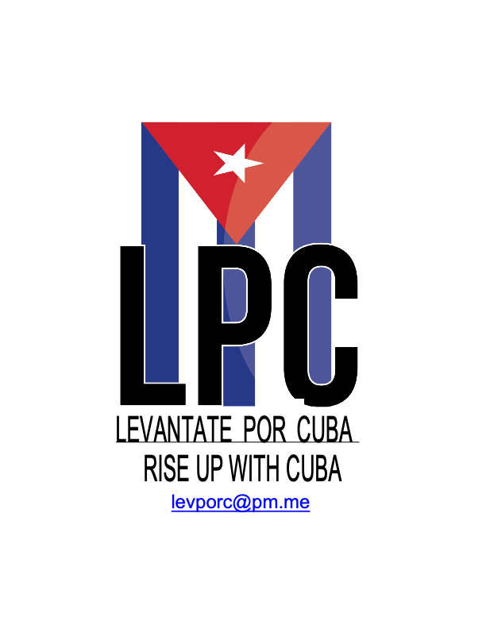
"Quien se levanta hoy con Cuba, se levanta para todos los tiempos"
"Whoever rises today with Cuba, rises for all time" – Jose Marti

Levantate por Cuba (LPC) Brigade Application

Solidarity Not Charity !

All Brigades Go to Santiago de Cuba

Fall, 2026 Brigade Application

Deadline: October 1, 2026

Please put 3 days, dates, times (specify time zone) here when you are available for an application interview on Signal app only:

Choose 1 Brigade Option

_____ 1 week: Saturday, November 7-Sunday, November 15, 2026

_____ 2 weeks: Saturday, November 7-Sunday, November 22, 2026

** All Brigade members must be in Miami no later than 4 pm Saturday and stay at the same hotel near the airport the day before we fly nonstop to Santiago de Cuba early Sunday morning.

1. Name

Date of Birth

Place of Birth

2. Home Address

3. Cell phone

4. email

5. Occupation

5.a. Education-please include any college, technical school, post-graduate education with name of each institution, major/field of study and years of graduation

6. Name on U.S. Passport, Passport #, Issue date, Expiration Date, Place of Birth

Please attach a high resolution copy of your photo & main passport page with this info

7. Have you traveled outside the U.S. before?

8. If yes to which countries and when: year and for how many days on each trip?

9. Please indicate if travel was leisure or for political solidarity or for work

10. Please indicate the name of any and all organizations who organized/sponsored each trip

11. Please describe what you did on each solidarity trip

12. Your organizing work history including what are you doing now

13. any political or labor or community organizations you belong to

14. have you been to Cuba before? If so did you go alone or with a group-if so which group and when and where in Cuba & what did you do, how long did you stay

15. why do you want to go with Levantate por Cuba on this brigade

16. What other causes do you link with Cuban solidarity that you support actively?

17. how should we connect with the millions of US residents who are also directly affected by the genocidal blockade of Cuba?

17.a. Do you think the US blockade of Cuba is 2-ways?
Does it affect people in the U.S.? If so how

18. what skills, experience, talents, wisdom do you bring to LPC that can help organize, fundraise, for this brigade and our Cuba solidarity work

19. Do you speak or read or write in Spanish?

20. If yes, would you be willing to translate on brigade trip in Cuba?

21. In solidarity are you willing to have Marazul Travel make All travel arrangements?: airplane tickets, Visa, Miami Hotel?

Marazul Tours has been doing this for the Cuba-US Solidarity Movement since 1979 x 47 years and is owned and run by Latina women.

https://marazultours.com/ Yes ___ or No ____

